* Chemistry Laboratory *

Ten Tips For Success In Lab Work

Keep in mind that a laboratory is an extension of the chemistry lecture; however, it is separate, and one credit hour and a grade will be earned. This laboratory class is something which has to be completed and UNDERSTOOD on a weekly basis. You cannot make up a lab unless it is permitted from an excused absence, AND during the week that particular lab is scheduled.
BE PREPARED AND WORK TO ACCOMPLISH A PARTICULAR RESULT.

YOU MUST KNOW WHAT YOU ARE DOING... All labs must be read and the procedure for accomplishing the correct results must be followed.

EVERY LAB IS A TEST... The lab is a performance of assigned directions and the accomplishment of a predictable result.

DATA MUST BE READ AND RECORDED IN THE ASSIGNED MANNER AND TO THE PROPER DEGREE OF ACCURACY. Follow the directions for recording data and know the degree of accuracy of the instruments with which you work.

YOU AND OTHERS IN THE LAB MUST BE SAFE ... Know the safety policies and regulations and follow them. There is no way to apologize after you have blinded, injured, or killed someone. THERE CAN BE NO "PLAY" IN A DANGEROUS SITUATION.

DO NOT DEPEND UPON SOMEONE ELSE TO DIRECT YOU THROUGH THE EXPERIMENT ... Most of the experiments will be individual efforts, and you cannot expect someone else to get you through. You are on your own, and you will be graded accordingly. If you have questions, I will be available to help you understand. I will not, however, guide you through. (WRITTEN TESTS WILL INDICATE PREPARATION)

TURN IN ALL DATA AND CALCULATIONS. Sometimes I might be able to give partial credit if I can determine the source of the error. MAKE SURE ALL DATA IS READABLE AND RECORDED IN THE PROPER PLACE ON DATA SHEET. (I will not search for data)

WHILE IN THE LABORATORY, ELIMINATE ALL OTHER DISTRACTIONS. Phones should be stored away. You cannot be concerned about football, dates, etc., and do a good job in lab. Finish the lab assignment and THEN be concerned about the other things.

ORGANIZE YOUR TABLE ... PUT THINGS AWAY WHICH ARE NOT IN USE.

LEAVE YOUR STATION CLEAN AND ORGANIZED. If you leave a mess, you will be penalized.

A visual Guide to Laboratory Equipment
Beaker | Erlenmeyer Flask | Florence Flask | Graduated Cylinder | Wide Mouth Bottle
Used to hold acids or liquids and to carry out reactions |  |  | Used to measure out accurate volumes of liquid | Used to contain a gas or for reactions
Funnel | 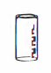  Shell Vial | Bunsen Burner | Ring Support  Iron Ring Support with clay triangle and Retort Stand
Used to transfer liquids to another container and when filtering out solids | Used to hold small  amounts of solid  substances | Used to provide heat | Used to support triangle or wire gauze during the healing process
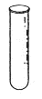  Test Tube | Test Tube brush | 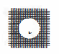Wire Gauze | Test Tube Holder
Used to hold small volumes of liquids | Used to clean test tube | Used to support a beaker on an iron ring during heating | Used to hold a test tube during heating or while still hot
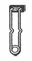Starter | 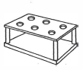Test Tube Rack | Clamp | Beaker Tongs
Used to ignite bunsen burner | Used to hold and store test tubes | Used to hold a buret, test tube, or flask to a ring/retort stand | Used to move beakers, especially when hot

Evapourating dish |  | 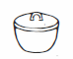  Crucible with Cover/Lid |  | 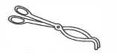  Crucible Tongs
Used to evapourate a solution to dryness |  | Used to heat small samples to high temperatures |  | Used to pick up a crucible
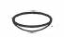  Watch Glass |  | Stirring Rod |  | 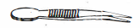Forceps
Used to cover a beaker or to hold a small amount of a substance |  | Used to stir or combine two or more substances in a test tube or a beaker |  | Used to pick up a small object or one that is hot
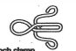  Pinch Clamp |  | Spatula |  | File
Used to close rubber tubing |  | Used to transfer small amounts of a solid |  | Used to cut glass tubing
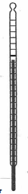  Thermometer | Pipet |  | Buret |  | 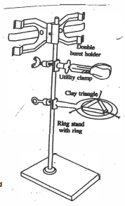
Used to measure the temperature of a substance | Used to transfer a specific volume liquid solution to a container |  | Used to deliver a measured amount of solution with a known concentration

